Student Name: __________________
Class and Section __________________
Total Points (20 pts) __________________
Due: Oct 3, 2016 before the class

Project: Execution time for Sorting

CSCI 2410 Data Structures and Algorithms
Armstrong Atlantic State University

Problem Description:

Write a program that obtains the execution time of selection sort, radix sort, bubble sort, merge sort, quick sort, and heap sort for input size 50000, 100,000, 150,000, 200,000, 250,000, and 300,000. Your program should create data randomly and print a table like this:

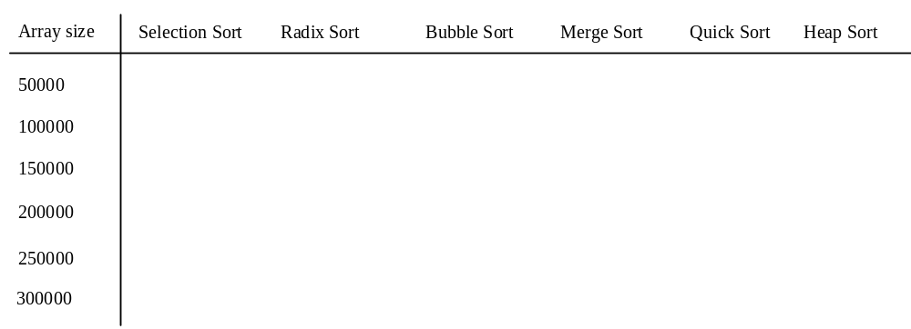

In the same program, obtain the execution time of selection sort, radix sort, bubble sort, and heap sort for input size 2,000,000, 3,000,000, 4,000,000, and 5,000,000.

(Hint: You can use the code template below to obtain the execution time.)

long startTime = System.currentTimeMillis();
perform the task;
long endTime = System.currentTimeMillis();
long executionTime = endTime - startTime;

Code:
Name the program Exercise23_13
Print the source code for your main method and for Radix Sort method.

Test:
Give me the screen shot of the table.

What to submit?

1. Email me this document.

2. Compile and Submit to LiveLab Exercise23_13 (you must submit the program regardless whether it complete or incomplete, correct or incorrect)

